Gas Gauge Update Instructions

This document contains proprietary information of Zebra Technologies Corporation and its subsidiaries

(“Zebra Technologies”). It is intended solely for the information and use of parties using the hardware/software

described herein. Such proprietary information may not be used, reproduced, or disclosed to any other

parties for any other purpose without the express, written permission of Zebra Technologies.

1. Hooking up the battery fixture

The battery fixture should be connected to the battery programmer by removing the wires from the terminal blocks and connecting them to the programmer terminal strip as shown below:
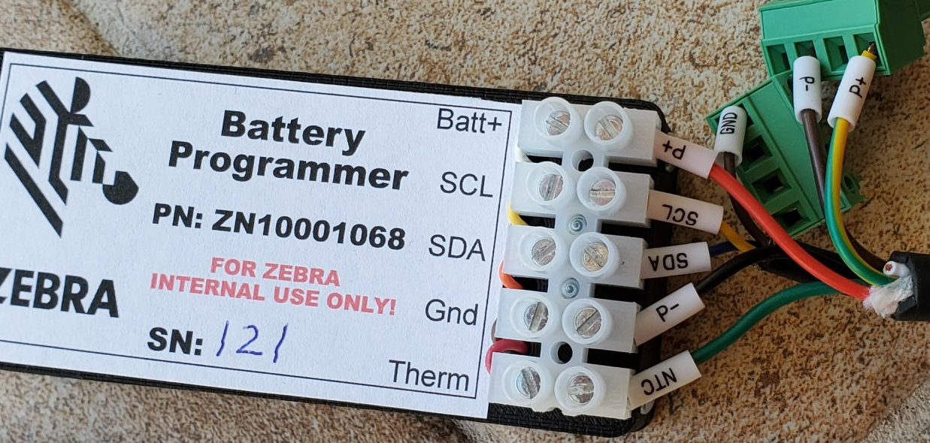

1. The wire labeled P+ goes to the Batt+ terminal on the programmer.

2. The wire labeled SCL goes to the SCL terminal on the programmer.

3. The wire labeled SDA goes to the SDA terminal on the programmer.

4. The wire labeled P- goes to the Gnd terminal on the programmer.

5. The wire labeled NTC goes to the Therm terminal on the programmer.

2. Terminal Software Installation

A serial communications program is required to use the Battery Programmer. If you have not installed one yet, we recommend TeraTerm, but other serial terminal programs may work. TeraTerm can be downloaded from: https://osdn.net/projects/ttssh2/downloads/74780/teraterm-4.106.exe/

Plug the box into your PC and make a note of the serial port it was assigned. After installing TeraTerm start it and you will see the following dialog, select “Serial” and then pick the port assigned to the box. It will probably be labeled “USB Serial Device”.
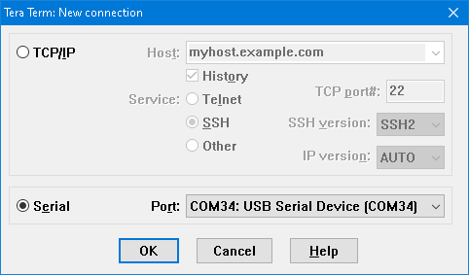

When the TeraTerm window opens you should see something like the following:
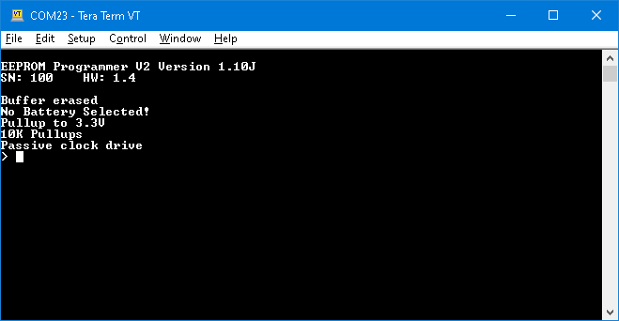

3. Check for the latest firmware

When the TeraTerm window is first opened the box displays the version of it’s firmware. Check the Battery Programmer Sharepoint site: https://zebra.sharepoint.com/sites/BatteryProgrammer for the latest firmware and update the box if needed. (Update instructions are in the instruction manual)

4. Copy the needed files onto the programmer

When the programmer is plugged into the USB you should also see an attached USB drive appear with the label “BATTPROG”. This drive is internal to the battery programmer. In order to update the battery certain files are needed. Copy all the .hex and .fs files from the supplied zip file to the root of the BATTPROG drive.

5. Select the battery type

Enter the battery select command ‘b’ followed by enter. You should see the list of batteries as shown below:
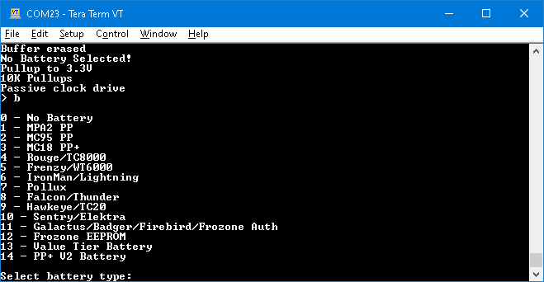

We want the PP+ V2 Battery, so type the number 14 followed by enter.

6. Update a gas gauge

Place a battery into the fixture. You should see the text “Battery detected!” on TeraTerm. Enter the update gas gauge command ‘ugg’ followed by enter. The box will now check the battery, check the files it needs for the update, and then update the battery. The process will take a little over a minute to finish. The LED will glow red during the update.

----DO NOT REMOVE THE BATTERY UNTIL THE UPDATE IS DONE ----

----Doing so will render the battery unusable----

When the update is finished, the LED will return to green, at that point the battery can be removed from the fixture.

